**Multistep form**

1. **Task Description**

Create a multi-step React form with sections like Personal Info, Address, and Payment, each validated individually. Include "Next" and "Back" buttons, disabling "Next" until current fields pass validation with error messages shown as needed. Use centralized state to manage data across steps, retaining input as users navigate. On the final step, validate all data before submission and show a confirmation message.

1. **Task Output Screenshot**

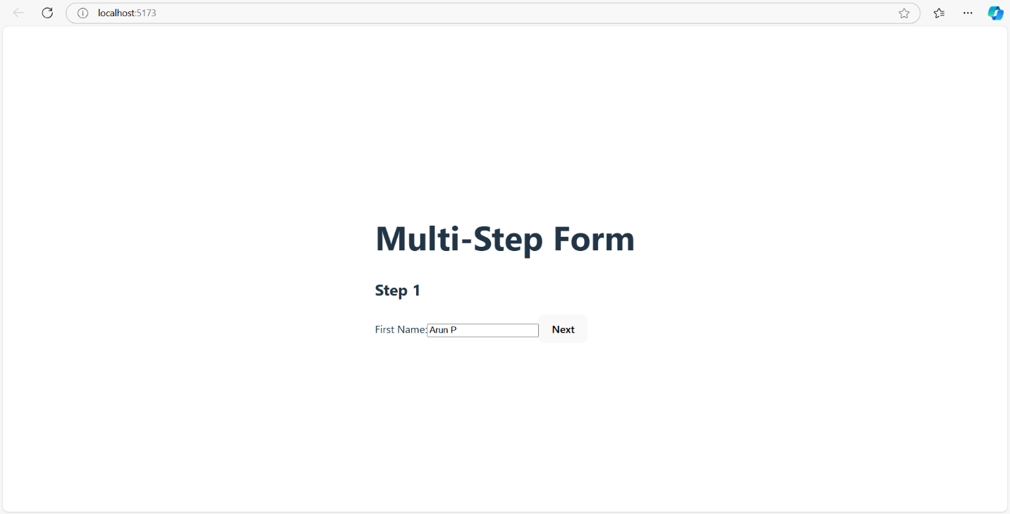

1. **Widget/Algorithm Used In Task**

* In this task, the primary widget used is a paginated table component designed for displaying tabular data in manageable portions.
* The JavaScript algorithm implemented handles page navigation, ensuring only a subset of rows is shown per page based on the current view.
* The pagination logic updates dynamically, showing the current page, previous and next buttons, and middle page buttons with dots, adapting to the user’s position within the page sequence.
* This approach optimizes data visibility and user experience by preventing overload and enabling smooth navigation.